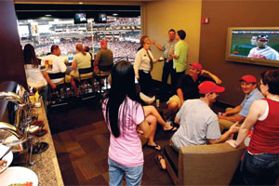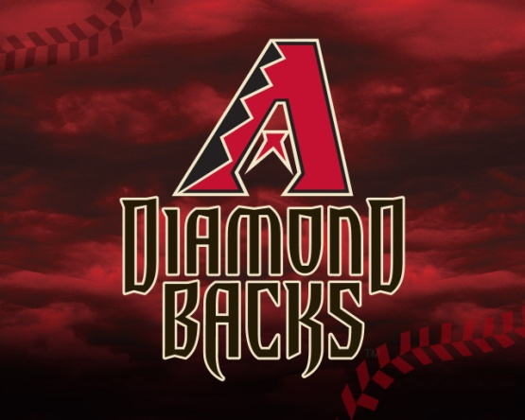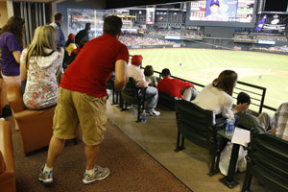

Diamondbacks Suite Experience for 4
Value: $800
Diamondbacks baseball tickets in suite @ Levy Restaurants for 4 with Food & Beverage and personal service.
Expires end of baseball season 2014.
Restrictions apply to certain baseball games. Alcohol not included.
Winner: Please contact Maricela Cruz at Foodspirits@me.com ahead of time for desired scheduled baseball games. Tickets will be Delivered once you request the tickets or will be put in will call.
